**Brain Tumor detection based on MRI Image using CNN**

PROJECT REPORT

Submitted in fulfilment for the JComponent of Soft Computing (SWE1011)

CAL Course in

M.Tech. – Software Engineering By

SUSEENDRAN S(18MIS0290) ADITHYAN P(18MIS0296) SIVAGNAMANIAN(18MIS0324)

Under the guidance of Dr. S. Hemalatha SITE

School of Information Technology and Engineering Winter Semester 2020-21

## TABLE OF CONTENTS

|  |  |  |
| --- | --- | --- |
| **CHAPTER NO.** | **TITLE** | **PAGE NO.** |
|  | **ABSTRACT** | 3 |
| **1.** | **Introduction** | 3 |
| **2.** | **General Architecture** | 4 |
| **3.** | **Dataset Specification** | 4 |
| **4.** | **Literature Review (all papers considered in a team)** |  |
|  | **4.1.Review on Various Schemes** | 5 |
|  | **4.2.Comparative study on various subtitles** | 15 |
|  | **4.3.Overview of the Review** | 21 |
| **5.** | **System design** |  |
|  | **5.1.FlowChart Diagram** | 25 |
|  | **5.2.Detailed Description of Modules** | 26 |
| **6.** | **Software Requirement Specifications** | 27 |
| **7.** | **Experimental Results & Discussion** |  |
|  | **7.1.Source code** | 27 |
|  | **7.2.Screenshots with Explanation** | 33 |
| **8.** | **References** | 39 |
| **Annexure** | **Attach PDF of main reference paper** |  |

**ABSTRACT:**

Brain tumor diagnosis is a daunting task in the early stages of life. However, with the addition of numerous machine learning algorithms, it has progressed. The subject of brain tumor automatic diagnosis is a hot topic these days. Patients' data, such as MRI images of the patient's brain, are used to diagnose a patient's brain tumor. Our problem here is to determine whether or not a tumor is present in the patient's brain. It is important to identify tumors at an early stage in order for a patient to live a healthy life. There is a large amount of literature on identifying these types of brain tumors and enhancing detection accuracies. In this project, we estimate the severity of a brain tumor using a Convolutional Neural Network algorithm, which produces accurate results.

# Introduction:

Brain Tumor is one of the most dangerous diseases which require early and accurate detection methods. Now most detection and diagnosis methods depend on the decision of neuro specialists, and radiologists for image evaluation which is possible to human errors and time consuming. The main purpose of this project is to build a robust CNN model that can classify if the subject has a tumor based on Brain MRI scan images with an acceptable accuracy for medical grade application.

# General Architecture:

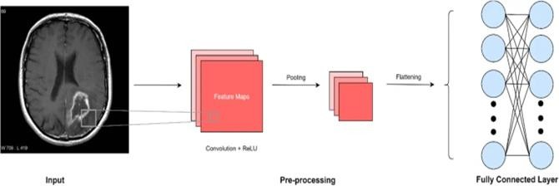

**Dataset Specification: Source:** [www.kaggle.com](http://www.kaggle.com/) **Healthy brain:**

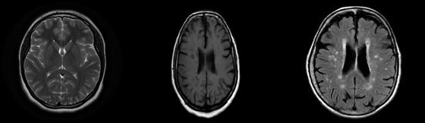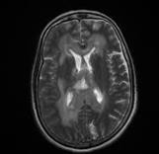

## Tumor Detected Brain:

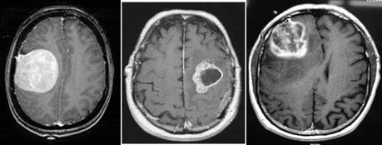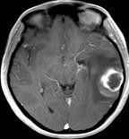

**Literature Review:**

**Review on Various Schemes:**

1. Seetha J, Raja S. S. Brain Tumor Classification Using Convolutional Neural Networks. Biomed Pharmacol J 2018;11(3).

## Literature review:

The research talks about the usage of the traditional classifiers such as K-Nearest Neighbour (KNN), Support Vector Machine (SVM),Deep Neural Network (DNN), local independent projection-based classification (LIPC), Cellular Automata (CA) in detecting brain tumors. All of these methods have some disadvantages, DNN- High Accuracy but High Complexity, LIPC- Low Accuracy, CA- Low Complexity but Low Accuracy. All these disadvantages lead to finding an efficient method to detect the brain tumor.

The Method is Known as Convolutional Neural Network,The reason for choosing CNN is because it has High Accuracy and Low Complexity. This paper uses the BRATS dataset of 2D MRI images containing both tumor and Non tumor. The algorithm depicts the steps used in the CNN and compares the results obtained from CNN to that of the Traditional Classifiers to find out that CNN has the Highest accuracy rate (97.5%) and low validation loss in detecting Brain Tumor than the traditional Classifiers. This paper suggests the usage of CNN over the Traditional Classifiers.

1. Pathak, K., Pavthawala, M., Patel, N., Malek, D., Shah, V., & Vaidya, B. (2019). Classification of brain tumor using Convolutional neural network. 2019 3rd International conference on Electronics, Communication and Aerospace Technology (ICECA).<https://doi.org/10.1109/iceca.2019.8821931>

## Literature review:

This research paper uses detection algorithm for Convolutional Neural Networks and watershed algorithms to segment the detected Brain tumor if any. The research paper also gives a brief description of the layers (Pooling Layer, Fully Connected Layer, Padding etc..) present inside the neural network and their usage. It uses Rectifier Activation Function (ReLU), It also uses data augmentation to maintain the balance in the dataset. 330 images has been used as an input to train the CNN. After it finds the Brain Tumor it segments the portion of the brain using the watershed algorithm.

Watershed Algorithm is a good algorithm for segmentation. The watershed algorithm then uses various methods to segment the tumor. The training accuracy of the CNN in this research paper is 98%. The validation accuracy is high and at the same time validation loss is also very less in CNN.

1. T. Hossain, F. S. Shishir, M. Ashraf, M. A. Al Nasim and F. Muhammad Shah, "Brain Tumor Detection Using Convolutional Neural Network," 2019 1st International Conference on Advances in Science, Engineering and Robotics Technology (ICASERT), Dhaka, Bangladesh, 2019, pp. 1-6, doi: 10.1109/ICASERT.2019.8934561.

## Literature review:

This research paper mainly compares the accuracy of traditional methods such as SVM, KNN, MLP, Logistic Regression, Naive Bayes and Random forest with the Convolutional neural network (CNN) in detecting the brain tumor. The paper explains about the methods used by the traditional classifiers such as Skull Stripping, Filtering and Enhancement, Segmentation using FCM, Morphological Operation, Tumor Contouring, feature extraction, Traditional Classifiers and Evaluation stage for detecting brain tumor and finds out that SVM gives the highest accuracy of 92.42% among all the Traditional classifiers.

On the other side the paper also shows the 5 layer methodology used by CNN to detect brain tumors. Convolution Layer, Max pooling, Flatten and two dense layers. The dataset is taken from BRATS which consists of 2D MRI Images containing both Tumor and Non-Tumor which are classified into class-0 and class-1. Using these layers and dataset, CNN gives a training accuracy rate of 97.87% with a split ratio of 80:20, higher than that of the SVM (92.42%) which is very compelling.

1. R. M. Prakash and R. S. S. Kumari, "Classification of MR Brain Images for Detection of Tumor with Transfer Learning from Pre-trained CNN Models," 2019 International Conference on Wireless Communications Signal Processing and Networking (WiSPNET), Chennai, India, 2019, pp. 508-511, doi: 10.1109/WiSPNET45539.2019.9032811.

## Literature review:

This research paper analyses the three CNN architectures - VGG16, ResNet and Inception. CNN has various Layers such as Pooling Layer, Convolutional Layer, Fully Connected Layer and Softmax Layer. Transfer Learning method is applied to CNN in this paper. Transfer Learning is a method which is effective to train CNN if there is Insufficient Training data. This paper then trains each of these architectures: VGG 16 is trained with more than One million images and the network has 41 layers, ResNet has 18, 34, 50,101 and 152 layers of architecture.

After Training with database these Models are then tested on the images taken from the dataset which was preset in the website of Harvard Medical school.This 3 Architectures’ results are then compared with Wavelet-Entropy and Naive Bayes Classifier which is used to detect brain tumors as well, The Accuracy of these 3 Architectures is 100% if done with data Augmentation, whereas Wavelet-Entropy and Naive Bayes Classifier has an Accuracy of 92.6%. Data Segmentation was used to improve the segmentation Accuracy. The result shows that it is better to use any one of these 3 Architectures for higher Accuracy.

1. Brain Tumor Detection and Classification Using Convolutional Neural Network Chirodip Lodh Choudhury;Chandrakanta Mahanty;Raghvendra Kumar;Brojo Kishore Mishra 2019 International Conference on Computer Science, Engineering and Applications (ICCSEA)

## Literature review :

This paper deals with the brain tumor detection using CNN. In this they classify the MR images as Tumor detected or Tumor not detected. The proposed model consists of 3 Layered CNN. Convolutional Neural net here the each image is filtered by a series of layers such as convolution, pooling, and fully connected layers. Model Description various activation functions are used they are Rectified linear units , Hyperbolic Tangent functions and sigmoid Activation function. They first load the images using OpenCV library, a python library used to manipulate and work with image data and converting the images into arrays and then train the model. After pre-processing and train, test set splitting. Model tuning is performed. At the end the result is predicted. In this paper they used accuracy, fscore, recall, accuracy, and confusion matrix to evaluate the model's performance. This model achieved the accuracy of 96.08%, with f-score of 97.3.

1. Brain Tumor Detection Using Convolutional Neural Network Tonmoy Hossain;Fairuz Shadmani Shishir;Mohsena Ashraf;MD Abdullah Al Nasim;Faisal Muhammad Shah 2019 1st International Conference on Advances in Science, Engineering and Robotics Technology (ICASERT)

## Literature review:

In this paper, the authors proposed the segmentation and detection of the brain tumor based on both traditional classifiers and Convolutional Neural Network. here they used six traditional classifiers namely Support Vector Machine (SVM), K-Nearest Neighbour (KNN), Multilayer Perceptron (MLP), Logistic Regression, Naïve Bayes and Random Forest . At last they applied Convolutional Neural Network (CNN) which is implemented using Keras and Tensorflow.in this paper they used two models. In First model they segmented the tumor by FCM and classified by traditional machine learning algorithms and the second model focused on deep learning for tumor detection. The methodology used for classification using Traditional classifier first they input the images and skull stripping ,means removing the skull portion from the MRI images and Filtering and Enhancement the input images and segmenting using Fuzzy C-Means clustering algorithm (FCM) and Morphological Operation were done and Tumor Contouring, The output of this image is the highlighted tumor area with a dark background and featue extraction and traditional classifiers wer done and at last they evaluating the stages. The methodology used in CNN they have used Five-Layer Convolutional Neural Network and implemented for tumor detection. The SVM gave the highest accuracy of 92.42% among the other traditional classifier.

1. CNN Based Brain Tumor Detection Harshini Badisa, Madhavi Polireddy, Aslam Mohammed. 2019 International Journal of Engineering and Advanced Technology (IJEAT)

## Literature review:

To detect the brain tumor of a patient , in this paper the authors consider the data of patients like MRI images of a patient’s brain . the proposed system of this paper was to provide a new methods of MRI images of Brain of a patient and pre-processing is done by Gaussian which is a linear filter and Then feature Extraction is done for the images by

GLCM features. Finally classification applied through an algorithm Convolutional neural networks which will identify the tumor regions. Here they have used five steps for methodology . First, Image Acquiring - Primary Phase the image are collected . Second Pre Processing - images are resized and applying Gaussian filters for a perfect input clear image . Third Feature Extraction - extract the features and characteristics of Images for easy detection of brain tumor. Fourth Classification - Convolutional neural networks algorithm is used for classification . The result of the filtered image, After the output of the segmented image we get the histogram features, shape features and GLCM features of the selected image from the dataset. The final output is Estimation of whether the tumor which is severe or not.

1. Ucuzal, Hasan & YASAR, Seyma & Colak, Cemil. (2019). Classification of brain tumor types by deep learning with convolutional neural network on magnetic resonance images using a developed web-based interface.

## Literature review:

In this research paper discuss about this study aims to develop a free web-based software based on deep learning that can be utilized in the diagnosis and detection of brain tumors (Glioma/Meningioma/Pituitary) on T1-weighted magnetic resonance images using convolutional neural network from deep learning algorithm. the free web-based software developed, it is believed that medical professionals and other health professionals can classify brain tumors faster and more accurately.

A recent study has developed a deep learning system established on CNN for classifying brain tumors on public data sets, containing 233 and 73 patients with a total of 3064 and

516 images on T1-weighted contrast-enhanced magnetic resonance images. The developed system in the study realizes a important performance with the best total accuracy rates of 96.13% and 98.7% for the two datasets, respectively and can successfully classify for brain tumor multi-classification tasks.

1. Basheera, S., & Satya Sai Ram, M. (2019). Classification of brain tumors using deep features extracted using CNN. Journal of Physics: Conference Series, 1172, 012016. https://doi.org/10.1088/1742-6596/1172/1/012016

## Literature review:

In this paper, Deep learning play a major role in medical automation, Convolutional Neural Networks (CNN) is an important machine learning technique for medical image segmentation and classification. Two data sets were formed to validate the proposed classifier. These two data sets included a total of 40 images (20 images each) and were heterogeneous with both normal and abnormal images. The term true positive is used to categorize correct classification of abnormality while true negative is used to categorize correct classification of normal image. The ability of the classifier is defined by the accuracy with which it discriminated between healthy and diseased states. The proposed classifier has an accuracy of 0.9 or 90% for data set DS1 while it is 1 or 100% for data set DS2. The sensitivity is another parameter which is used to define the classifier performance. It is nothing but the fraction of actual positives that have been correctly predicted. The sensitivity of the proposed classifier is 0.93(93%) and 1(100%) for dataset DS1 and dataset DS2 respectively.

1. Tonmoy Hossain , Fairuz Shadmani Shishir2 , Mohsena Ashraf &, Faisal Muhammad Shah5$ <https://www.researchgate.net/publication/337768246>

## Literature review:

In this paper, Image segmentation plays a significant role in medical image processing as medical images have different diversities. For brain tumor segmentation, we used MRI and CT scan images. MRI is most vastly used for brain tumor segmentation and classification. They used Fuzzy C-Means clustering for tumor segmentation which can predict tumor cells accurately. In the traditional classifier part, we applied and compared the results of different traditional classifiers such as K-Nearest Neighbor, Logistic Regression, Multilayer Perceptron, Naïve Bayes, Random Forest, and Support Vector Machine. Among these traditional ones, SVM gave us the highest accuracy of 92.42%. In

this paper, they proposed a method to extract brain tumor from 2D Magnetic Resonance brain Images (MRI) by Fuzzy C-Means clustering algorithm which was followed by traditional classifiers and convolutional neural network. The experimental study was carried on a real-time dataset with diverse tumor sizes, locations, shapes, and different image intensities.

1. Neethu Ouseph C ,Shruti K. IOSR Journal of Electrical and Electronics Engineering (IOSR-JEEE)

## Literature review:

This paper presents a reliable detection method based on CNN that reduces operators and errors. The Convolutional Neural Network (CNN) is used in convolving a signal or an image with kernels to obtain feature maps. The image processing techniques such as image conversion, feature extraction and histogram equalization have been developed for extraction of the tumor in the MRI images of the cancer affected patients. A suitable Fuzzy Classifier is developed to recognize healthier tissue from cancer tissue. The whole system is divided into two phases: firstly learning/Training Phase and secondly Recognition/Testing Phase. The aim of the project is to detect and extract the of tissue abnormalities by using the biochemical features.

This paper aims at giving more information about brain tumor detection and extraction. The target area is segmented and the evaluation of the nature of the tumor using the tool suggested here helps the doctors in diagnosis the treatment plan making and state of the tumor monitoring. The advantages of this system are it improves the segmentation level and spatial localization of the image and also improves the efficiency compared to the other system. It consumes less time for computation and becomes easier to train with fewer parameters than other network. The accuracy of the system can be much more improved by using artificial neural network as the classifier.

1. Choudhury, C. L., Mahanty, C., Kumar, R., & Mishra, B. K. (2020). Brain tumor detection and classification using Convolutional neural network and deep neural network. 2020 International Conference on Computer Science, Engineering and Applications (ICCSEA). <https://doi.org/10.1109/iccsea49143.2020.9132874>

## Literature review:

This Research paper proposes a new system based on CNN which detects the presence of brain Tumor in a person’s brain. This paper proposes a 3 layered CNN Architecture each having 108, 64,32 perceptron. The model proposed is built on top of the keras, which is supported by the Tensor Flow, a simple python Machine Learning API. The shape of the input going to be fed on the network is of the dimension 366, 310 and 1 corresponding to width-height-grayscale.This architecture Uses various Activation functions such as Rectified linear units (ReLU), Hyperbolic Tangent function- Tanh and Sigmoid Activation function.The goal of this paper is to build a new system with very few steps of pre-processing and also aims to produce the results in 35 epochs. The Proposed Architecture when tested with the images has an accuracy of 96.08% with f-score 97.3 while the training loss was 0.402%.

1. Brain Tumor Detection Using Model from MR Images using Convolutional Neural Network Chinta Someswararao;R Shiva Shankar;Sangapu Venkata Appaji;Vmnssvkr Gupta 2020 International Conference on System, Computation, Automation and Networking (ICSCAN)

## Literature review :

In this paper ,they proposing the mechanism for detecting the brain tumor from the given MR images by applying machine learning algorithm such as CNN .They are using three phases in methodology to detect the brain tumor, Data pre-processing: this is the initial step. This phase is done using Download dataset – the dataset downloaded from UCI data it consists of MR images with tumor and images having no tumor, Data Cleaning

the images are resized for the training. Model Design: first the all dataset was divided into two parts train data and test data . here for this paper they use 75% of data as training data and remaining data as testing data.they have done the classification using CNN for segmentation and extract features from the images. Finally the given input images is detected by classifying the images as yes or no .Model Evaluation: using accuracy to evaluate the model. The CNN model used in this paper is used to predict the target accurately.

1. Y. Basotho, A. Kamalakannan and G. Rajamanickam, "Detection and Classification of Brain Tumor in MRI Images using Deep Convolutional Network," 2020 6th International Conference on Advanced Computing and Communication Systems (ICACCS), Coimbatore, India, 2020, pp. 248-252, doi: 10.1109/ICACCS48705.2020.9074375.

## Literature review:

This paper discusses about the automatic brain tumor detection and classification of MR Images using deep learning algorithm. The manual evaluation process is time- consuming and needs domain expertise to avoid human errors. To overcome this issue, Faster R-CNN deep learning algorithm was proposed for detecting the tumor and marking the area of their occurrence with Region Proposal Network (RPN). The selected MR image dataset consists of three primary brain tumors namely glioma. For the Faster R- CNN algorithm implementation, a deep convolutional network architecture called VGG- 16 was used as base network. Detection and classification results of the algorithm demonstrate that it is able to achieve an average precision of 75.18% for glioma, 89.45% for meningioma and 68.18% for pituitary tumor. The mean average algorithm achieved a precision of 77.60% for all classes. This method can also be generalized to other medical applications, such as skin lesion segmentation and classification.

1. Brain Tumor Detection Analysis Using CNN: A Review Sunil Kumar;Renu Dhir;Nisha Chaurasia 2021 International Conference on Artificial Intelligence and Smart Systems (ICAIS)

## Literature review:

This paper was based on Brain Tumor Detection Analysis Using CNN. The methodology were they have taken MR images as the input dataset and image pre processing were done using the given input dataset and image segmentation were done by three methods Thresholding Method , Region growing method , Region growing method and they are using water shed algorithm . Feature extraction and Feature optimization which play a crucial role in brain image processing . They classified using CNN by performing the Convolution Layer , Rectified Linear Unit (ReLU) , Pooling- a dimensionality reduction algorithm that reduces each function map’s dimension. The main aim of this paper is to predict t high accuracy with a low error rate

## Comparative study on various subtitles:

|  |  |  |  |  |
| --- | --- | --- | --- | --- |
| **(Year, Authors)** | **Methodology or Techniques used (mention specific algorithms or recent technologies)** | **Advantages** | **Issues** | **Metrics used (those are used to justify the performance of the used scheme)** |

|  |  |  |  |  |
| --- | --- | --- | --- | --- |
| **Year :** 2018 **Authors:** J. Seetha and S. Selvakumar Raja | Convolutional Neural Networks | CNN has high sensitivity and low false-negative rate | The algorithm has been trained to identify only the presence of brain tumors. It cannot identify different types of brain tumors. | *Gradient Descent Algorithm to calculate Loss Function. |
| **Year:** 2019 **Authors:** Miss Krishna Pathak, Mr. Mahekkumar Pavthawala, Miss Nirali Patel, Mr.  Dastagir Malek, Prof. Vandana Shah and Prof. Bhaumik Vaidya | Convolutional Neural Network | The validation loss is very much less in Convolutional Neural Network. | CNN does not encode the position and orientation of the object. | *Cross Entropy Loss  *Validation Accuracy |

|  |  |  |  |  |
| --- | --- | --- | --- | --- |
| **Year:** 2019 **Authors:**Tonmoy Hossain, Fairuz Shadmani Shishir, Mohsena Ashraf MD Abdullah, Al Nasim and Faisal Muhammad Shah | 5 Layered Convolutional Neural Network | Using the Convolutional Neural Network gave higher accuracy (97.87%) of  detection of brain tumor than the traditional method(92.42%). | CNNs do not have coordinate frames which are a basic component of human vision | *Adam optimizer  *Binary cross- entropy to calculate loss function  *Confusion Metrics |
| **Year:** 2019 **Authors:** R. Meena Prakash and R. Shantha Selva Kumari | Three CNN models are used, tested and compared: AlexNet, VGG- 16 and VGG-19 | All the three models tested gave 100% of accuracy in this research paper. | If the CNN has several layers then the training process takes a lot of time if the computer doesn’t consist of a good GPU. | *Loss Function to compute the error rate. |
| **Year**:2019 **Authors:**Chandrakan ta Mahanty, Raghvendra Kumar, Chirodip Lodh Choudhury Brojo Kishore Mishra | convolutional neural network (CNN) | Using CNN achieved the accuracy of 96.08%, with fscore  of 97.3 | The issues faced in this method are : Training time is high because of using various activation function | Metrics used:confusion matrix |

|  |  |  |  |  |
| --- | --- | --- | --- | --- |
| **Year:**2019 **Authors:**Tonmoy Hossain; Fairuz Shadmani Shishir; Mohsena Ashraf; MD Abdullah Al Nasim; Faisal Muhammad Shah | Convolutional Neural Network (CNN), FCM ,  Support Vector Machine (SVM), K-Nearest Neighbor (KNN), Multilayer Perceptron (MLP), Logistic Regression, Naïve Bayes and Rando | CNN gave the accuracy 97.87% than the traditional classifier SVM gave us the highest accuracy of 92.42%.Reduce the noise from the training set. | The issues faced in this method are  :Support vector machine show the low accuracy rate than CNN | Metrics used  :confusion metrics of the classifier |
| **Year:**2019 **Authors:**Harshini Badisa, Madhavi Polireddy, Aslam Mohammed | Convolutional Neural Network, Gaussian Filter | CNN improves the detection accuracies | The issues faced in this method are : CNN has several layers then the training process takes a lot of time | Metrics used: Confusion metrics |
| **Year:** 2019  **Authors:** Hasan Ucuzal, Şeyma YAŞAR & Cemil Çolak | Convolutional neural network | the best total accuracy rates of 96.13% and 98.7%  for the two datasets | Complexity And dataset | Classified accuracy |

|  |  |  |  |  |
| --- | --- | --- | --- | --- |
| **Year:** 2019  **Authors:** Shaik Basheera and M. Satya Sai Ram | Convolutional neural network | classifier has an accuracy of 0.9 or 90% for data set DS1 while it is 1 or 100% for data set DS2. | Using large dataset to reduction of noise will get complicated | Confusion accuracy |
| **Year: 2019**  **Authors:** Tonmoy Hossain1 , Fairuz Shadmani Shishi | Convolutional neural network | Support vector machine give the highest accuracy of 92.42% | The training process takes a more time | Validation accuracy |
| **Year:** 2019 **Authors:** Neethu Ouseph C, Shruti K | Convolutional neural network | CNN improves accuracy | Many parameters have to be tuned | sensitivity |
| **Year:** 2020 **Authors:**Chirodip Lodh Choudhury, Chandrakanta Mahanty, Raghvendra Kumar and Brojo Kishore Mishra | CNN or ConVet algorithm | CNN requires very few steps of pre- processing (training) only 35 epochs to test and produce the results. | Image quality and scope may be insufficient for reliable interpretation, especially in patients | *ADAM  Optimiser  *Brain Cross Entropy to calculate loss function  *Confusion Matrix |

|  |  |  |  |  |
| --- | --- | --- | --- | --- |
| **Year:**2020 **Authors:**Chinta Someswararao, R Shiva Shankar, Sangapu Venkata Appaji, VMNSSVKR Gupta | Convolutional Neural Network (CNN) | CNN improves the accuracy and prediction level | The issues faced in this method are : using large dataset the reduction of noise will get complicated | Metrics used: Accuracy , confusion matrix |
| **Year:** 2020  **Authors:** Yakub Basotho, Anandhanarayanan Kamalakannan & Govindaraj Rajamanickam | Region-CNN And VGG-16 | Kaggle dataset named Brain MRI Images for Brain Tumor Detection . | It takes a lot of time to train the network. | IOU accuracy |
| **Year:**2021  **Authors:**Sunil Kumar, Renu Dhir, Nisha Chaurasia | Convolution Neural Network | The accuracy method is most arise using CNN. Improving the accuracy with a low rate of error | The issues faced in this method are : A Convolutional neural network is significantly slower due to an operation such as maxpool | Metrics used : Accuracy is 92 percent |

**Overview of the Review:**

All the above mentioned research papers use a methodology known as Convolutional Neural Networks to detect brain tumor. The main reason to use CNN is because of the higher Accuracy rate in detecting the brain tumor than that of the traditional methods such as Support Vector Machine (SVM), Random forest etc. CNN uses many layers such as Convolutional Layers, Max Pooling Layers,

Fully Connected Layers, Softmax Activation Layers on the 2D MRI images of the brain which is the main reason for the High accuracy rate obtained. The validation loss is also less in CNN compared to other Traditional networks. All this gives CNN an edge over other methods in detecting brain tumors.

## Reference paper[1]:

The best methodology used in this paper is the usage of SoftMax function to classify objects with likely values between 0 and 1.

## Reference paper[2]:

Usage of Gradient Descent Algorithm to calculate the Loss Function. Loss function is really important to improve accuracy.

## Reference paper[3]:

In this research paper Data Augmentation used in CNN. Data Augmentation balances the data set used by CNN to get proper results.

## Reference paper[4]:

Usage of Sigmoid as an activation Function is definitely the best part one because it helps CNN to reduce the Computational time taken.

## Reference paper [5]:

Methodology used in this paper , first load the images using OpenCV library, a python library used to manipulate and work with image data. The images are converted into numpy arrays which are then feed to our CNN based model after proper pre-processing and train, test set splitting. Model tuning is performed. At the end metrics have been calculated and assessed.

## Reference paper [6]:

Methodology of Tumor Segmentation and Classification Using Traditional Classifiers are Skull Stripping – removal of the skull portion from the MRI images using the following steps , they are Otsu Thresholding and Connected Component Analysis. Filtering and Enhancement- Gaussian blur filter was used.

Segmentation using FCM: Fuzzy C-Means clustering algorithm was used for segmentation. Morphological Operation and Tumor cluster extraction was done. Feature Extraction were done and the We used six traditional machine learning classifiers which are K-Nearest Neighbor, Logistic Regression, Multilayer Perceptron, Naïve Bayes, Random Forest, and Support Vector Machine to get the accuracy of tumor detection

.Methodology Using CNN , Load the input dataset , adding a convolution layer,passing the convolution kernel into max pooling layer , pooled feature map is used to get the single column vector, processing the vector, final dense layer applying sigmoid as the activation function and Validation stage and performing evaluation.

## Reference paper [7]:

Methodology used in this paper , Image acquiring - Primary Phase,images were collected. Pre Processing - The images which are collected are subjected to preprocessing. In Pre-processing stage basic steps are image resizing and applying Gaussian filters for a perfect input clear image for easy identification of an image. Segmentation - Segmentation . Feature Extraction - extract the features and

characteristics of Images for easy detection of brain tumor . Classification - Convolutional neural networks algorithm is used for classification of brain images.

## Reference paper [8]:

The CNN algorithm consists of one or more convolutional layers, subsampling layers, and one or more fully connected layers. In training and testing stages, accuracy, precision, sensitivity, specificity, F-Score, Matthew's Correlation Coefficient (MCC) and G-mean metrics together with 95% confidence interval (CI) levels are calculated in the assessment of classification performance of the model developed by using deep learning algorithm.

## Reference paper [9]:

Pre-trained CNN were used to extract deep features through transfer learning.

Here, the pre-trained CNN model chosen was CNN_S [19] which contained five Convolutional layers and three fully connected layers. CNN_S had hyper parameters as follow: weight decay 5 x 10^-4 , momentum 0.9, initial learning rate 10 . The initial rate was down to one tenth, once the validation error stopped diminution. Next, linear transformation is used to normalize the gray values to range [0,255].

## Reference paper [10]:

In our proposed methodology, there are two distinct model for segmentation and detection of Brain tumor. First model segmented the tumor by FCM and classified by traditional machine learning algorithms and the second model focused on deep learning for tumor detection. Segmentation by FCM gives better result for noisy clustered data set. Though it takes more execution time, it retains more information.

## Reference paper [11]:

In this paper, they used a Medical imaging segmentation is generally addressed in the modern as a classification problem where the previous methods can be divided into two main classes. The first class includes discriminative segmentation methods that are mainly based on image features and the training data. The second class contains

generative methods which require additional information about the space domain. The accurate segmentation of tumors and its intra-tumoral structures is significant not only for treatment planning, but also for follow-up evaluations. The manual segmentation is time-consuming and subjected to inter- and intra-rater errors and makes difficult to characterize. Thus, physicians usually use rough measures for evaluation. For these reasons, accurate semiautomatic or automatic methods are required

## Reference paper [12]:

The best methodology in the research paper is the usage of **transfer Learning**, because it manages the insufficiency of data in CNN. As Transfer Learning will help reduce the computing resources needed as well.

## Reference paper [13]:

Methodology used in this paper, they done using three phases called Data Pre-processing, Model Design, and Model Evaluation. In Data Preprocessing two phases can be done, Download dataset and Data Cleaning. In Model Design, it can be explained through two phases, Splitting Data and Classification . In Model Evaluation , use of accuracy to evaluate the model.

## Reference paper [14]:

An automatic brain tumor detection and classification method was implemented using Faster R-CNN algorithm. The VGG-16 architecture was chosen as a base network in Faster R-CNN for generating convolutional feature map to produce tumor region proposals followed by classification.

## Reference paper [15]:

Methodology used in this paper , inputting the dataset and image were pre processed and segmented and the feature extraction is done and Feature Optimization- play a crucial role in brain image processing . classification using CNN is done by Convolution Layer , Rectified Linear Unit (ReLU) and Pooling layer.

# System design:

## Flow Chart Diagram :

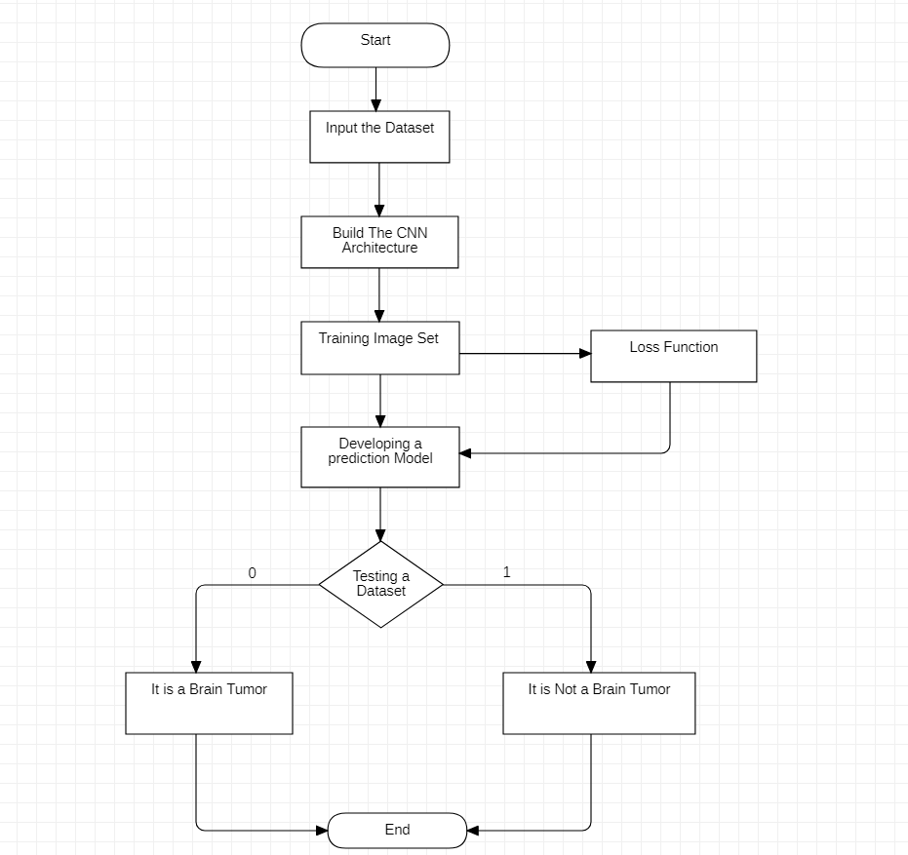

**Detailed Description of Modules:**

**Building the CNN Architecture:**

To train the Dataset we have to build a CNN Model or CNN Architecture. The layers present in the Architecture are

* + CONV2D
  + BatchNormalization
  + Maxpooling2D

## Training the Dataset:

We are training the CNN Architecture by using a Dataset downloaded from the website “[www.kaggle.com](http://www.kaggle.com/)”. The Dataset has the MRI Images of both Brain Tumor and Non Brain Tumor Images. We are training the dataset for 30 epochs.

## Validating the loss:

At each Epoch during the training we incur some losses and Validation Losses. We are implementing a Loss Function to calculate the Loss and the validation Loss and we are plotting a graph for theLoss and the validation Loss after the completion of calculation.

## Testing the Dataset:

After Training the Dataset we have a test dataset which has a mixed bag of both brain tumor and Non Brain Tumor Images to test the CNN Architecture. The Testing will also show the Accuracy of the CNN architecture in classifying those images between Brain Tumor and Non Brain Tumor Image.

# Software Requirement Specifications:

* + **Application:** Anaconda Navigator (JupyterLab)
  + **Language:** Python

# Experimental Results & Discussion:

## Source code:

import os import keras

from keras.models import Sequential

from keras.layers import Conv2D, MaxPooling2D, Flatten, Dense, Dropout,

BatchNormalization from PIL import Image import numpy as np import pandas as pd

import matplotlib.pyplot as plt plt.style.use('dark_background')

from sklearn.model_selection import train_test_split from sklearn.preprocessing import OneHotEncoder

encoder = OneHotEncoder() encoder.fit([[0], [1]])

# 0 - Tumor # 1 - Normal

# This cell updates result list for images with tumor

data = [] paths = [] result = []

for r, d, f in os.walk(r'C:\Users\Suseendran\Brain Tumor Dataset\brain_tumor_dataset\yes'):

for file in f:

if '.jpg' in file: paths.append(os.path.join(r, file))

for path in paths:

img = Image.open(path) img = img.resize((128,128)) img = np.array(img)

if(img.shape == (128,128,3)): data.append(np.array(img)) result.append(encoder.transform([[0]]).toarray())

paths = []

for r, d, f in os.walk(r"C:\Users\Suseendran\Brain Tumor Dataset\brain_tumor_dataset\no"):

for file in f:

if '.jpg' in file: paths.append(os.path.join(r, file))

for path in paths:

img = Image.open(path) img = img.resize((128,128)) img = np.array(img)

if(img.shape == (128,128,3)): data.append(np.array(img)) result.append(encoder.transform([[1]]).toarray())

data = np.array(data) data.shape

result = np.array(result) result = result.reshape(139,2)

x_train,x_test,y_train,y_test = train_test_split(data, result, test_size=0.2, shuffle=True, random_state=0)

model = Sequential()

model.add(Conv2D(32, kernel_size=(2, 2), input_shape=(128, 128, 3), padding = 'Same'))

model.add(Conv2D(32, kernel_size=(2, 2), activation ='relu', padding = 'Same'))

model.add(BatchNormalization()) model.add(MaxPooling2D(pool_size=(2, 2)))

model.add(Dropout(0.25))

model.add(Conv2D(64, kernel_size = (2,2), activation ='relu', padding = 'Same')) model.add(Conv2D(64, kernel_size = (2,2), activation ='relu', padding = 'Same'))

model.add(BatchNormalization()) model.add(MaxPooling2D(pool_size=(2,2), strides=(2,2))) model.add(Dropout(0.25))

model.add(Flatten())

model.add(Dense(512, activation='relu')) model.add(Dropout(0.5)) model.add(Dense(2, activation='softmax'))

model.compile(loss = "categorical_crossentropy", optimizer='Adamax') print(model.summary())

y_train.shape

history = model.fit(x_train, y_train, epochs = 30, batch_size = 40, verbose = 1,validation_data = (x_test, y_test))

plt.plot(history.history['loss']) plt.plot(history.history['val_loss']) plt.title('Model Loss') plt.ylabel('Loss') plt.xlabel('Epoch')

plt.legend(['Test', 'Validation'], loc='upper right') plt.show()

def names(number): if number==0:

return 'Its a Tumor' else:

return 'No, Its not a tumor'

from matplotlib.pyplot import imshow

img = Image.open(r"C:\Users\Suseendran\Desktop\Softcomputing project\testdataset\21 no.jpg")

x = np.array(img.resize((128,128))) x = x.reshape(1,128,128,3)

res = model.predict_on_batch(x)

classification = np.where(res == np.amax(res))[1][0] imshow(img)

print(str(res[0][classification]*100) + '% Confidence' + names(classification))

from matplotlib.pyplot import imshow

img = Image.open(r"C:\Users\Suseendran\Desktop\Softcomputing project\yes\Y18.jpg") x = np.array(img.resize((128,128)))

x = x.reshape(1,128,128,3)

res = model.predict_on_batch(x)

classification = np.where(res == np.amax(res))[1][0] imshow(img)

print(str(res[0][classification]*100) + '% Confidence' + names(classification))

## Screenshots with Explanation: Importing the required libraries:

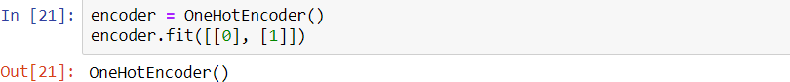

**Training with the Brain Tumor Dataset:**

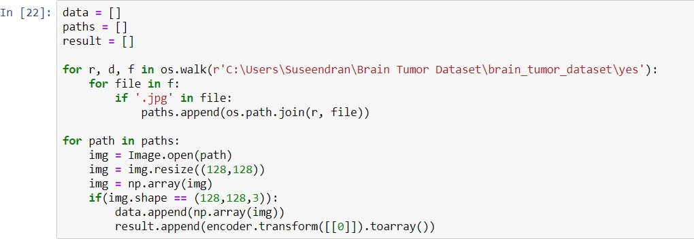

**Training with the Non Brain Tumor Dataset:**

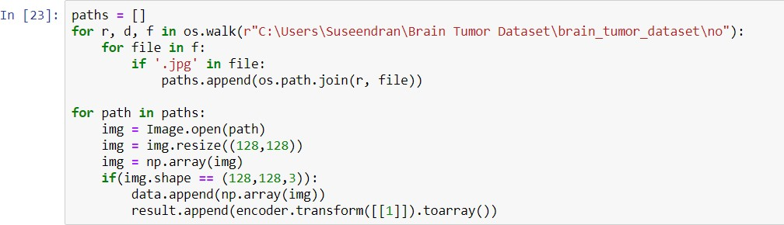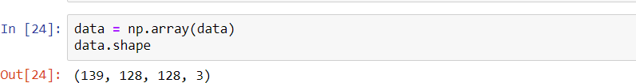





**CNN Architecture :**

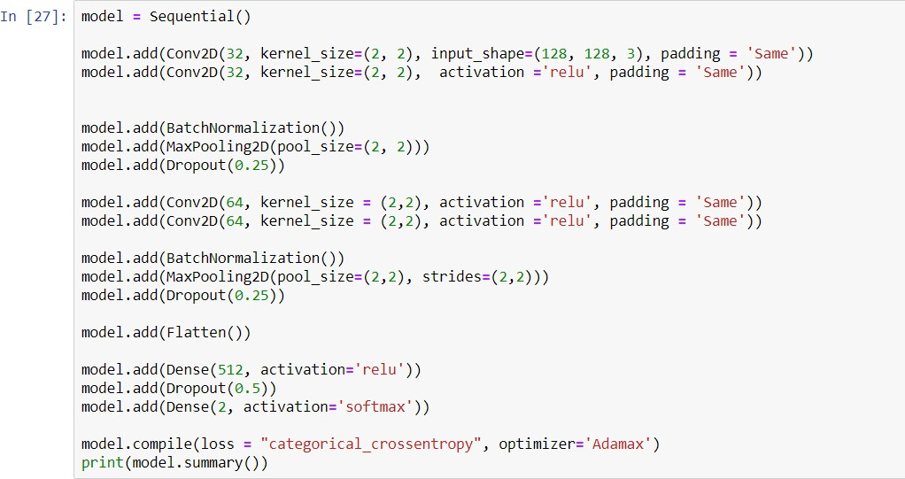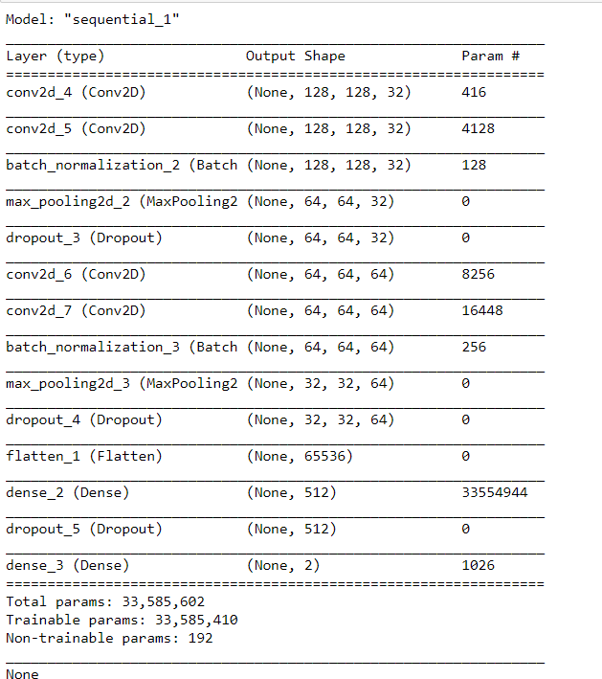



**Training the Dataset using 30 epochs:**

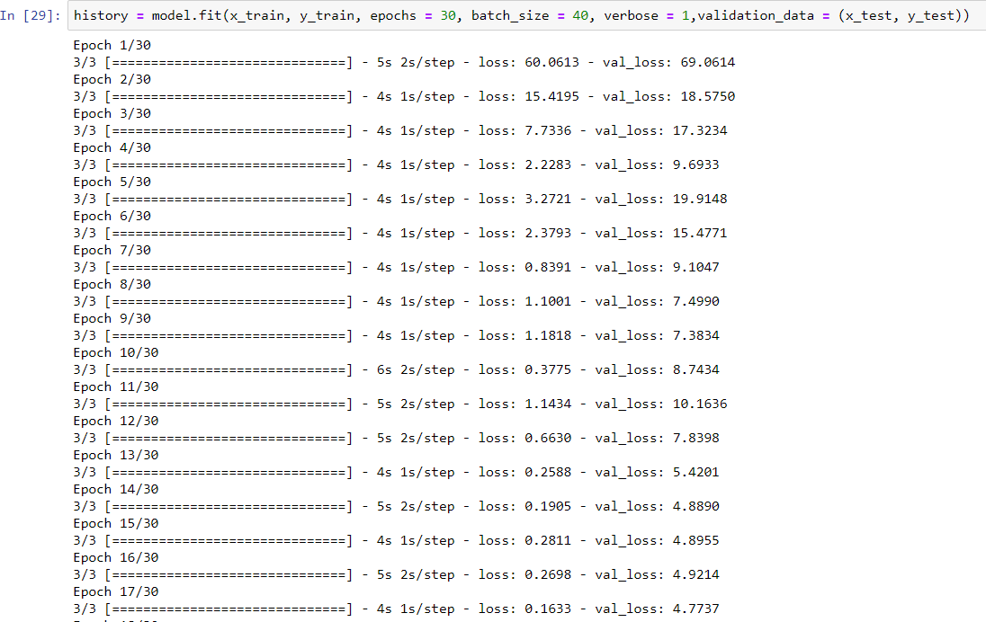

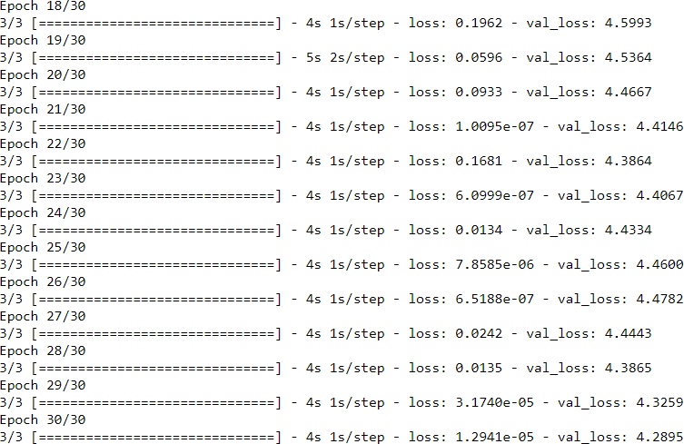

**Plotting the Validation Loss with x-axis as Epoch and y-axis as Loss:**

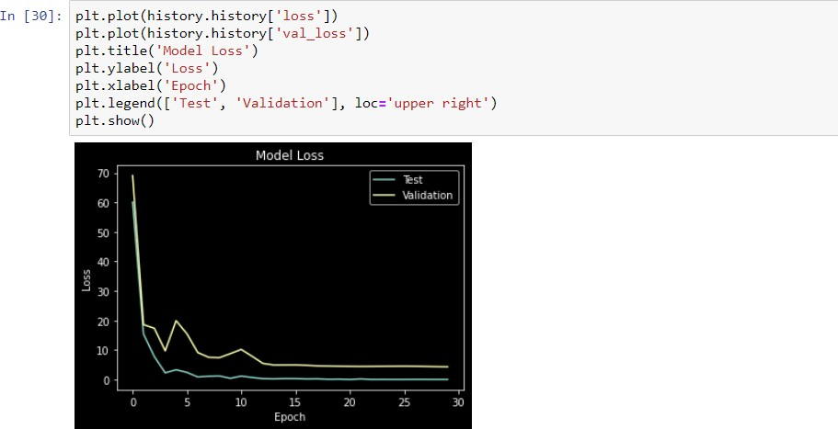

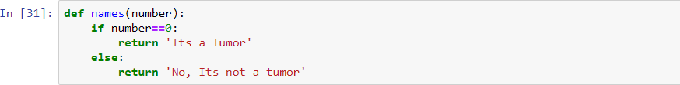

**Testing the Dataset and showing its Accuracy:**

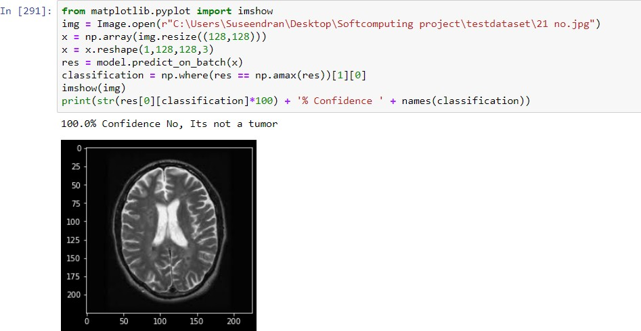

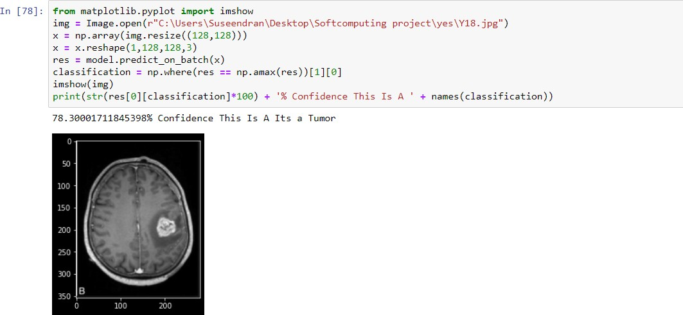

**References:**

1. Seetha J, Raja S. S. Brain Tumor Classification Using Convolutional Neural Networks. Biomed Pharmacol J 2018;11(3).
2. Pathak, K., Pavthawala, M., Patel, N., Malek, D., Shah, V., & Vaidya, B. (2019). Classification of brain tumor using Convolutional neural network. 2019 3rd International conference on Electronics, Communication and Aerospace Technology (ICECA).<https://doi.org/10.1109/iceca.2019.8821931>
3. T. Hossain, F. S. Shishir, M. Ashraf, M. A. Al Nasim and F. Muhammad Shah, "Brain Tumor Detection Using Convolutional Neural Network," 2019 1st International Conference on Advances in Science, Engineering and Robotics Technology (ICASERT), Dhaka, Bangladesh, 2019, pp. 1-6, doi: 10.1109/ICASERT.2019.8934561.
4. R. M. Prakash and R. S. S. Kumari, "Classification of MR Brain Images for Detection of Tumor with Transfer Learning from Pre-trained CNN Models," 2019 International Conference on Wireless Communications Signal Processing and Networking (WiSPNET), Chennai, India, 2019, pp. 508-511, doi: 10.1109/WiSPNET45539.2019.9032811.
5. Brain Tumor Detection and Classification Using Convolutional Neural Network Chirodip Lodh Choudhury;Chandrakanta Mahanty;Raghvendra Kumar;Brojo Kishore Mishra 2019 International Conference on Computer Science, Engineering and Applications (ICCSEA)
6. Brain Tumor Detection Using Convolutional Neural Network Tonmoy Hossain;Fairuz Shadmani Shishir;Mohsena Ashraf;MD Abdullah Al Nasim;Faisal Muhammad Shah 2019 1st International Conference on Advances in Science, Engineering and Robotics Technology (ICASERT)
7. CNN Based Brain Tumor Detection Harshini Badisa, Madhavi Polireddy, Aslam Mohammed. 2019 International Journal of Engineering and Advanced Technology (IJEAT)
8. Ucuzal, Hasan & YASAR, Seyma & Colak, Cemil. (2019). Classification of brain tumor types by deep learning with convolutional neural network on magnetic resonance images using a developed web-based interface.
9. Basheera, S., & Satya Sai Ram, M. (2019). Classification of brain tumors using deep features extracted using CNN. Journal of Physics: Conference Series, 1172, 012016. https://doi.org/10.1088/1742-6596/1172/1/012016
10. Tonmoy Hossain , Fairuz Shadmani Shishir2 , Mohsena Ashraf &, Faisal Muhammad Shah5$ <https://www.researchgate.net/publication/337768246>
11. Neethu Ouseph C ,Shruti K. IOSR Journal of Electrical and Electronics Engineering (IOSR-JEEE)
12. Choudhury, C. L., Mahanty, C., Kumar, R., & Mishra, B. K. (2020). Brain tumor detection and classification using Convolutional neural network and deep neural network. 2020 International Conference on Computer Science, Engineering and Applications (ICCSEA). <https://doi.org/10.1109/iccsea49143.2020.9132874>
13. Brain Tumor Detection Using Model from MR Images using Convolutional Neural Network Chinta Someswararao;R Shiva Shankar;Sangapu Venkata Appaji;Vmnssvkr Gupta 2020 International Conference on System, Computation, Automation and Networking (ICSCAN)
14. Y. Basotho, A. Kamalakannan and G. Rajamanickam, "Detection and Classification of Brain Tumor in MRI Images using Deep Convolutional Network," 2020 6th International Conference on Advanced Computing and Communication Systems (ICACCS), Coimbatore, India, 2020, pp. 248-252, doi: 10.1109/ICACCS48705.2020.9074375.
15. Brain Tumor Detection Analysis Using CNN: A Review Sunil Kumar;Renu Dhir;Nisha Chaurasia 2021 International Conference on Artificial Intelligence and Smart Systems (ICAIS)

Brain Tumor Detection Model from MR Images using Convolutional Neural Network

Dr. Chinta Someswararao,

Dept of CSE, SRKR Engineering College,

Bhimavaram, AP, India

R Shiva Shankar Dept of CSE, SRKR Engineering College,

Bhimavaram, AP, India

Sangapu Venkata Appaji Dept of CSE,

KKR & KSR Institute of Technology and Sciences, Guntur, A.P, INDIA

VMNSSVKR Gupta Dept of CSE,

SRKR Engineering College,

Bhimavaram, AP, India

Abstract— **The anomalous development of cells in brain causes brain tumor that may lead to death. The rate of deaths can be reduced by early detection of tumor. Most common method to detect the tumor in brain is the use of Magnetic Resonance Imaging (MRI). MR images are considered because it gives a clear structure of the tumor. In this paper we proposed an novel mechanism for detecting tumor from MR image by applying machine learning algorithms especially with CNN model.**

***Keywords***— **Brain tumor; Machine learning; MRI; CNN**

* 1. INTRODUCTION

Brain tumor detection is one of the most difficult task in the analysis of medical images. A person is effected with brain tumor when there is an abnormal or unusual growth of the cells in his/her brain. Globally brain tumors become a very big reason for human death. By using image processing early detection of tumor is possible. This can be done by scanning the human brain. A brain scan is a picture that describes internal anatomy of the brain. There are different biomedical device that uses different scanning techniques to scan the brain such as X-ray, CT-scan and MRI [1-5].

MRI scan is a technique that depends on the magnetic fields and radio frequency pulses in the water molecules present in human body. MRI scan is more efficient than CT scan, because CT scan doesn't make use of radio frequency. Different machine learning algorithms are applied on the input image and classifies whether an image contains tumor or not[1-5].

* 1. LITERATURE SURVEY

Al-Ayyoub, M., Husari et al.,[6] proposed a model that detects the brain tumor with MRI images. The MRI images are classified to an image with tumor and without tumor. For this they make use of two popular tools known as ImageJ and MATLAB. They extract 10 different feature fromevery image to detect the tumor.

Komal Sharma, Akwinder Kaur et al.,[7] MR human brain images are classified by using supervised techniques like artificial neural networks, support vector machine, and unsupervised techniques like self organization map (SOM), fuzzy c-means when combined with feature extraction techniques.

Amin, J., Sharif et al.,[8] consider dataset that contains 86 images, where 49 tumor and 37 non-tumor images were collected from Nishtar Hospital Multan, Pakistan. BRATS 2013 challenge dataset consists of thirty cases with ground truth annotations in which 20 belong to HG and 10 to LG tumors. BRATS 2015 has 273 cases in which 54 LG and 220 HG gliomas are included. Classifiers are trained using 10-fold cross validation. All sample slices group into k random subsamples, where one subsample is employed for learning and rest for testing. They make use of MATLAB software to perform this.

Kapoor, L, et al., [9] discussed several techniques which are used in each phase of image processing. Pre-processing involves processes like noise reduction and noise removal, image reconstruction, conversion to grayscale, image enhancement. They discussed many filtering techniques used to sharpen or smoothen the images like Median Filter, Gaussian Filter, etc. Otsu thresholding, Genetic Algorithm, k means Clustering, Watershed Segmentation are some of the techniques discussed in the segmentation phase. The author also discussed the advantages and disadvantages of the various segmentation techniques. This survey paper concludes with various image processing techniques that are used in Medical Image Processing.

Reddy, D, et al.,[10] proposed the unconstrained growth of bizarre cells in brain known as the Brain Tumor. Magnetic Resonance Image (MRI) was used as an input image. For the prevention of noise form, image pre-processing technique was utilized. Median Filter was used for the preprocessing of the MRI images. K-Means Clustering and thresholding was used in the segmentation phase to segment the images. In detecting the tumors, this methodology was strong and the abnormal cells were bounded in MRI images other than the complicated shape of the tumor as shown in the experimental results. Additional features can also be extracted to make the system more sensitive to the texture and other factors.

* 1. METHODOLOGY

Brain Tumor detection methodology can be explained with three phases called Data Pre-processing, Model Design, and Model Evaluation. The actual process is shown in Fig 1.

IEEE ICSCAN 202 ISBN 978-1-7281-6202-7



**Data Pre-processing**

Data cleaning

repository

**Model Design**

train_test_split(X, Y, test_size = 0.25)

Training instances

Testing instances

Model is trained with labelled images

Model is tested with images

**Model evolution**

Evaluation Metrics

**Classification**

Download dataset form UCI

Fig 1. Structure of the model

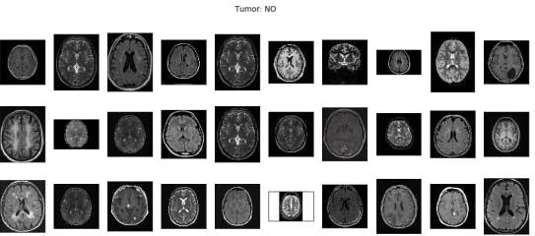***Data Pre-Processing:*** For any machine learning project data pre-processing is the most crucial and initial step. In this the raw data was collected and making it useful for machine learning model. In the proposed architecture the data pre processing can be done in two phases Download dataset and Data Cleaning.

***Download dataset:*** The dataset is downloaded from the UCI data repository. The image data that was used for this problem is Brain MRI Images for Brain Tumor Detection. It consists of MRI scans of two classes

* NO - no tumor, encoded as 0 [ Shown in Fig 2(a) ]
* YES - tumor, encoded as 1 [ Shown in Fig 2(b) ]

Fig 2(a) Tumor :: No

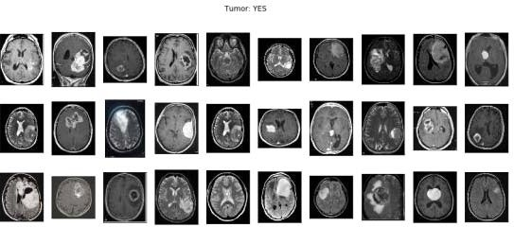

Fig 2(b) Tumor :: Yes

IEEE ICSCAN 202 SBN 978-1-7281-6202-7

***Data cleaning:*** In data cleaning any null values in the dataset are removed. As this is the image dataset the images are resized for training the model more efficiently. The images are resized to the dimensions of (224,224).

***Model Design:*** Model design can be explained through two phases, Splitting Data and Classification

***Splitting data:*** The whole dataset was divided into two parts called as train data and testing data. Training data is used to train the model and Testing data was used to test the model. In this project 75% of the data was taken as training data and 25% was taken as testing data.

***Classification:*** As the dataset contains images convolutional neural network is applied on the dataset. Convolutional Neural Network (CNN) [11-13] is used for learning how to segment images. CNN extracts features directly from pixel images with minimal preprocessing. It is a light deep neural network architecture designed for performing semantic segmentation. In Convolutional Neural Network the input image is augmented and the model is build. Finally the input image is classified as YES or NO. Original image is shown in Fig 3 and augmented images are shown in Fig 4.

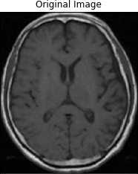

Fig 3 original image

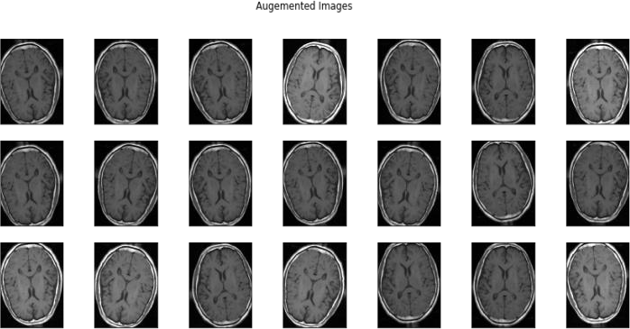

Fig 4 Augmented images

***Model Evaluation:*** There are many evaluation metrics to evaluate the model .We make use of accuracy to evaluate the model.

***Accuracy:*** Accuracy shows how well the model predicts the class. Mathematically accuracy is defined as the truly predicted instances divided by the total number of instances.

* 1. RESULTS

The CNN model gives the model accuracy and model loss graphs. The model accuracy is shown in Fig 5(a). The model loss is shown in Fig 5(b). Figure 5(a) shows that the accuracy was increasing and loss is decreasing, Figure 5(b) shows that model is predicting the target class accurately.

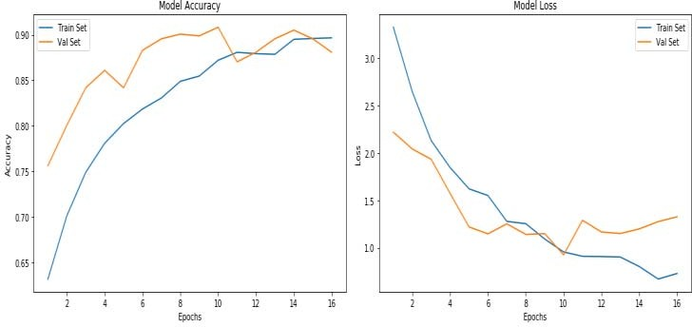

Fig 5(a) Model accuracy Fig 5(b) Model loss

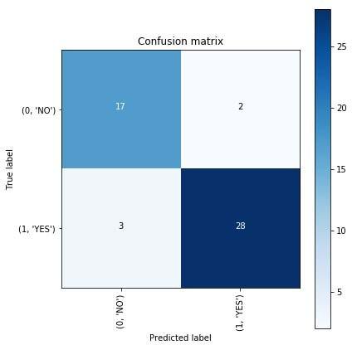

Fig 6(a) confusion matrix for validation data

IEEE ICSCAN 202 SBN 978-1-7281-6202-7

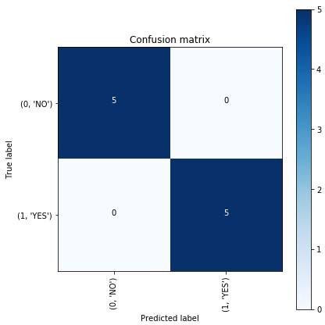

Fig 6 (b) Confusion matrix for test data

Confusion matrix for validation is shown in Fig 6(a). From the confusion matrix (Fig 6(a)) the following conclusions are made

* + There are total 19 instances in the training set that are labeled as NO but the model correctly predicts 17as NO and incorrectly predicts 2 as YES.
  + There are total 31 instances in the training set that are labeled as YES but the model correctly predicts 28 as YES and incorrectly predict 3 as NO.

Confusion matrix for testing data is shown in Fig 6(b). From the test set confusion matrix (Fig 6(b)) all classes are correctly classified. Hence the accuracy of testing data is 100%.

* 1. CONCLUSIONS

This paper was a combination of CNN model classification problem for predicting whether the subject has brain tumor or not & Computer Vision problem for automate the process of brain cropping from MRI scans. The final accuracy is much higher than 50% baseline (random guess). However, it could be increased by larger number of train images or through model hyper parameters tuning.

REFERENCES

1. Toğaçar M, Cömert Z, Ergen B. , "Classification of Brain MRI Using Hyper Column Technique with Convolutional Neural Network and Feature Selection Method.", Expert Systems with Applications,2020.
2. Shivhare SN, Sharma S, Singh N. , "An efficient brain tumor detection and segmentation in MRI using parameter- free clustering", Machine Intelligence and Signal Analysis, Springer, pp. 485-495, 2019.
3. Amin J, Sharif M, Raza M, Saba T, Anjum MA., "Brain tumor detection using statistical and machine learning method. Computer methods and programs in biomedicine", pp. 69-79, 2019.
4. Siar M, Teshnehlab M., "Brain Tumor Detection Using Deep Neural Network and Machine Learning Algorithm", 9th International Conference on Computer and Knowledge Engineering (ICCKE) , IEEE, pp. 363-368, 2019.
5. Saba T, Mohamed AS, El-Affendi M, Amin J, Sharif M. , "Brain tumor detection using fusion of hand crafted and

deep learning features", Cognitive Systems Research, pp.221-30, 2020.

1. Al-Ayyoub, M., Husari, G., Darwish, O., & Alabed-alaziz,

A. , "Machine learning approach for brain tumor detection", 3rd International Conference on Information and Communication Systems - ICICS ’12, 2012

1. Komal Sharma, Akwinder Kaur, Shruti Gujral, "A review on various brain tumor detection techniques in brain MRI images", IOSR Journal of Engineering (IOSRJEN) , pp.6- 12, 2014
2. Amin, J., Sharif, M., Raza, M., Saba, T., & Anjum, M. A., "Brain Tumor Detection using Statistical and Machine Learning Method", Computer Methods and Programs in Biomedicine, 2019
3. L. Kapoor, S. Thakur, “A survey on brain tumor detection using image processing techniques”, International Conference on Cloud Computing, Data Science & Engineering, 2017

[10]D. Reddy, Dheeraj, Kiran, V. Bhavana, H. Krishnappa, “Brain Tumor Detection Using Image Segmentation Techniques”, International Conference on Communication and Signal Processing (ICCSP), 2018

1. Özyurt F, Sert E, Avci E, Dogantekin E. , "Brain tumor detection based on Convolutional Neural Network with neutrosophic expert maximum fuzzy sure entropy.", Measurement., 2019.
2. Sharma P, Wahlang I, Sanyal S, Maji AK. , "Classification of Brain MRI Using Deep Learning Techniques", Soft Computing: Theories and Applications , Springer ,pp. 559- 569, 2020.
3. Sajid S, Hussain S, Sarwar A. , "Brain tumor detection and segmentation in MR images using deep learning", Arabian Journal for Science and Engineering, pp. 9249-61, 2019.

IEEE ICSCAN 202 SBN 978-1-7281-6202-7